travel SOP – travel arranger

Purpose
This guideline provides instruction to the travel arranger in organizing travel for employees of the Office of the Ombudsman who have been authorized to travel.

Scope
This guideline applies to employees of the Office of the Ombudsman for the Department of National Defence and the Canadian Forces (DND/CF)

Associated Documents/ Templates
- NJC Travel Directive
- Annex A: Travel Arranger Checklist
- Annex B: Travel Arranger Document Checklist
- Memorandum on Travel, Hospitality, Conference and Event Expenditures (THCEE) April 2015
- Individual Travel Authorization DND 2999 Form (Local travel)
- Record of Travel Expenses Form
- DND Travel Authority Matrix
- Traveler SOP

Contacts
- ClaimsX Help Desk
- Canadian Forces Support Unit (Ottawa) [CFSU (O)]
- Hogg Robinson Group Shared Travel Services (HRG-STS) Telephone Help Line: 1-866-857-3578
- Finance team

Roles and Responsibilities
Roles | Responsibilities
Travel Arranger: | Provide information to the traveler in the preparation of travel arrangements
Travel Arranger: | Final booking in HRG for lodging and transportation
Travel Arranger: | Processing traveler’s claims in ClaimsX
Travel Arranger: | Assigning financial (FIN) coding and transmitting it to the Finance team.
Travel Arranger: | Assembles the file in accordance with the CFSU(O) audit requirements. See Annex B
Travel Arranger: | Delivers the completed original hard copy to the finance team for review and filing.
Finance Team: | Finance team to reserve funds in DRMIS
Finance Team: | Will Liaise with CFSU(O) claims audit section
Finance Team: | Review and filing of original hard copy
Responsibility Centre (RC) Manager: | Reserve funds in budget

Operating Procedures

Gather Traveler Information and Provide TAN
- The arranger must obtain the title of the trip, the traveler’s name, their Personal Record Identifier (PRI) and travel dates. All of this information should be recorded on the Travel Arranger Checklist.
- Obtain completed DND2999 Form and the Hospitality/ Event Request form from the traveler
  - Ensure that the form is filled out correctly and all the required signatures have been acquired.

HRG-STS
- Obtain the HRG-STS estimates for travel from the traveler. (Hotels and Transportation only)
- Finalize the itinerary and book the travel in HRG-STS
  - Purchase plane/train ticket and book the hotel
  - Ensure you keep original documentation in the file.
  - Advise traveler of final arrangements
- Ensure all travel details are correct and assign Travel Authorization Number (TAN) and complete the booking procedure.
- For training on the HRG-STS website please follow the steps below.

Step 1:
- Log into the HRG-STS website.

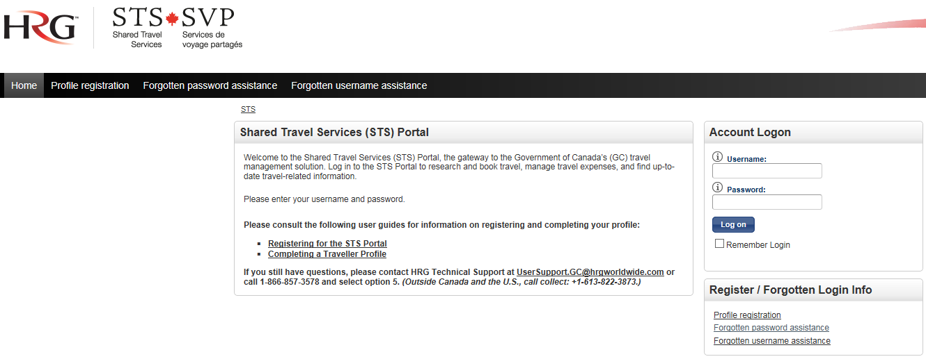

Step 2:
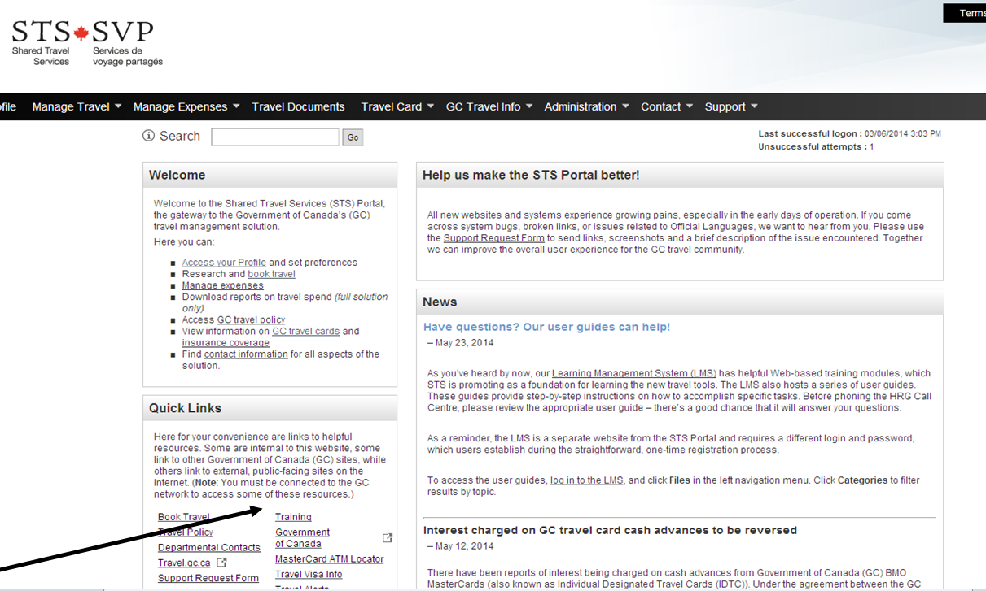
In the Quick Links section click on “Training”.

Step 3:

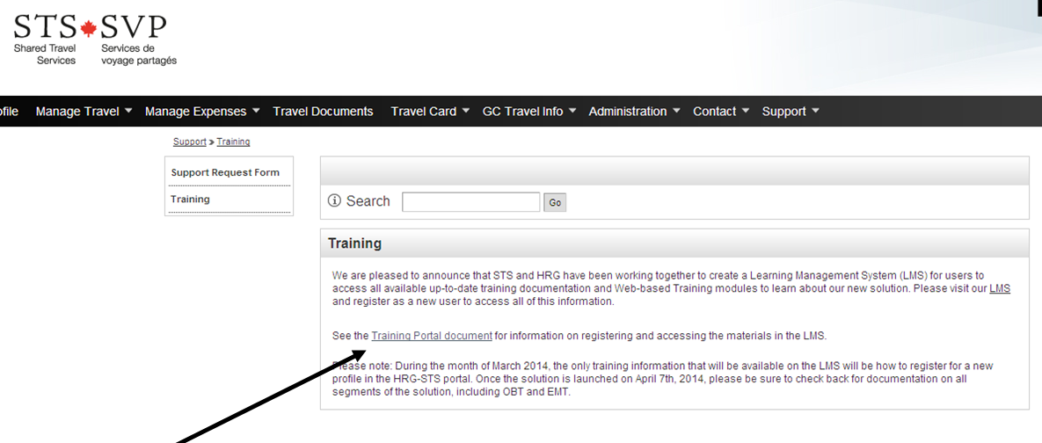
A new screen will open. Click on “Training Portal document” to access training materials.

Step 4:

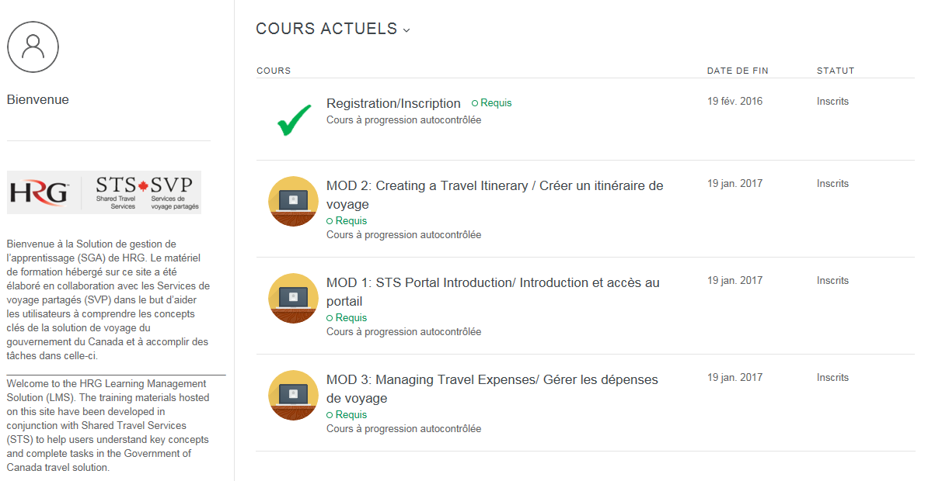

ClaimsX
- All travel arrangers must take ClaimsX training which can be done through the ClaimsX homepage under resources.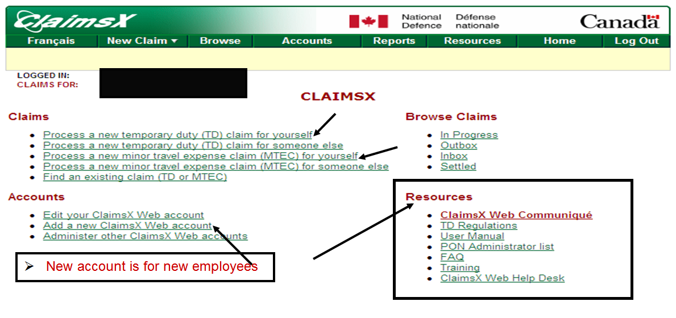
To process a new temporary duty claim select one of the following.
To create a new ClaimsX Web account or to add or administer an account click on the above links.

- All travel arrangers must get special authorization to access other traveler’s accounts. This authorization is requested by the Director, Corporate Services to the ClaimsX Help Desk.
- Open ClaimsX and login (same as PC Login info)
- The first time you log in you will need to create an account, follow the prompts to do so.
- For first time travelers request a void cheque from them and enter banking information to complete the traveler’s profile on ClaimsX.
- Assign FIN Coding from finance. It is the responsibility of the RC managers to reserve funds in their budget.
- Create, verify and print ClaimsX Pre-Authorization document and get claimants signature and Section 32 approval.
- Get ClaimsX e-approval from Section 32.
- Bring signed paper copy of documents to finance
- Initiate a new Travel Duty (this is ClaimsX terminology and is used when overnight travel is required) and input all the required information provided to you by the traveler (As per ClaimsX requirement)
- Print ClaimsX Travel Order and Claim document and get the traveler’s signature as well as the Section 32 approving authority signatures
- Get the ClaimsX e-approval from Section 32.
- Hold on to the Travel Order and Claim document until the traveler returns.

Minor Travel Expense Claim (MTEC)
- Obtain approval via email before completing a Minor Travel Expense Claim (MTEC)
- For local travel where there is no overnight stays please use (MTEC) in ClaimsX.

Financial Coding (Sample)
- Sample of FIN Coding:
  - Fund Commitment (Traveler Initial’s followed by first day of trip)
Ex: **Paul Mercier leaving for Vancouver on Sept 1, 2015 – (PM150901)
- Cost Centre: Ex: 0162BJ – They are paying for the trip
- General Ledger (GL): According to the purpose of the trip
Ex: Employee Training – (2138)
- List of GL’s:
2106 | Domestic Travel – Military Members
2128 | Military Travel – Other Reasons
2137 | Internal Governance & Management (Civilian Only) – Travel
2138 | Civilian Travel – Employee Training
2141 | Civilian Travel – Other Reasons
2145 | Non Taxable Travel of Non-Government Employees – Travel
2217 | Civilian Travel – Support Direct Delivery Core Mandate
2220 | Civilian Travel Stakeholder Engagement

After Travel
- Get Record of Travel Expenses Form from traveler within 5 days of return
- Input all the required information in ClaimsX, print the Travel Order and Claim document and get signatures from the claimant and the Section 34 approving authority.
- Get ClaimsX e-approval for Section 34.
- Assemble the file as per Travel Arranger Document Check list (Annex B). Then bring the completed original hard copy file to the finance team for review and filing.
- Finance will monitor the payment of the claim in DRMIS and inform the traveller when complete

Work Flow (Service Standards and Routings)

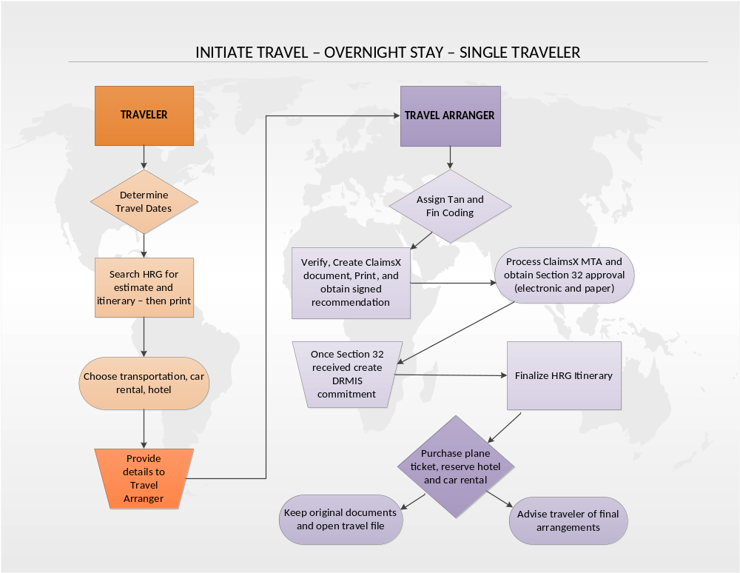

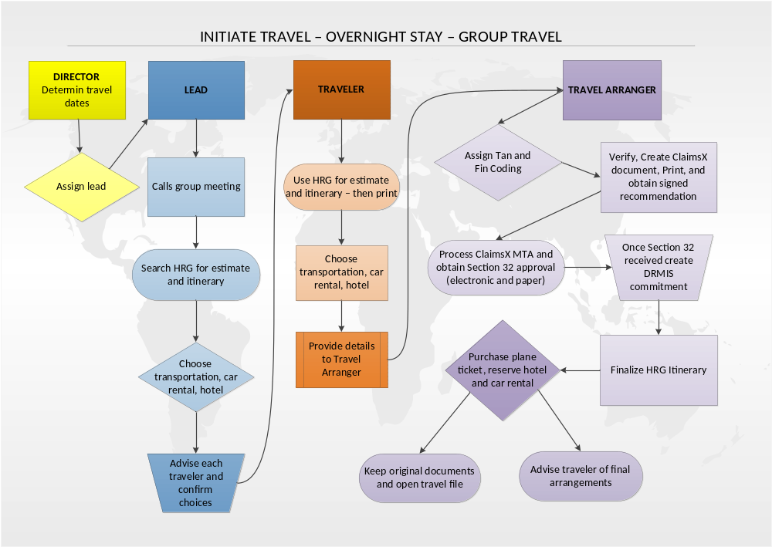

ANNEX A

TRAVEL ARRANGER CHECKLIST
Step |  |  | Addressed  (√)
1 | Trip title:
1 | Traveler's name:
1 | PRI:
2 | Verify credit card # in HRG profile
2 | Travel dates | Departure:  Return:
2 | Assign TAN Number | AAU4
2 | Estimate from HRG - Transport and hotel only
2 | Book travel in HRG | Locator #:
3 | ClaimsX coding | Claim #: 01003802
3 | ClaimsX coding | Fund: L101
3 | ClaimsX coding | GL:
3 | ClaimsX coding | Cost Center: 0162B
3 | ClaimsX coding | Commitment :
3 | ClaimsX coding | # of lines:
4 | Expenditure initiation event form
5 | Verify that the DND2999 form is complete and has appropriate signatures.  G:\FINANCE\Forms\THCEE
6 | Print Initiated ClaimsX document
6 | Get claimant's signature and sec 32 approval
6 | Get ClaimsX e-approval
7 | Create a DRMIS commitment  (Finance will be responsible for inputting  the commitment in DRIMIS)
7 | Fill in Record of Travel Expenses form
7 | Get claimant's signature and sec 34 approval
7 | Stamp each page with "send to cashier"
7 | File original documents in the travelers file
8 | After Finance confirmed that the claim was processed, close commitment and notify claimant by email.

ANNEX B

Travel Arranger Document Checklist
Item | Pages Needed: | Order  within batch: | Comments/Issues: | (√)
1 | Page 1 of Travel Order and Claim:  Including- Section 32 with signature | Page 1
2 | Page 4 of Travel Order and Claim:  Including- Section 34 with signature | Page 2
3 | Pages 2,3 (and any others) of Travel Order and Claim:  Details of Itinerary and Transportation/Car rentals/Lodging/Meals, Etc. | Page 3, 4
4 | Copies of Receipts (Hotel, Car Rentals, Taxi, Food, Etc.) | Page 6+
5 | Copies of Boarding Passes | Page 7+
6 | E-Ticket/Itinerary | Page 8+
7 | Travel Approvals | Page 9+

8 Glossary of Terms

The following is the glossary of acronyms used in this document.

CFSU (O) | Canadian Forces Support Unit (Ottawa)
DND/CF | Department of National Defence and the Canadian Forces
DRMIS | Defence Resource Management Information System
FIN | Financial
GL | General Ledger
HRG-STS | Hogg Robinson Group - Shared Travel Services
MTEC | ClaimsX terminology - Minor Travel Expense Claim (no overnight stays)
NJC | National Joint Council
PRI | Personal Record Identifier
RC | Responsibility Centre
TAN | Travel Authorization Number
THCEE | Travel, Hospitality, Conference and Event Expenditures
Travel Duty | ClaimsX terminology (overnight stays)

